EXPERIMENT 13: THREAT INTELLIGENCE FOR SOC

AIM

To understand how cyber threat intelligence (CTI) is used in a SOC to detect and respond to threats.

PROCEDURE

- Study the concept of threat intelligence and its importance in SOC.
- Learn about indicators of compromise (IOCs) and threat intelligence types.
- Understand the threat intelligence lifecycle (collection → analysis → action).
- Analyze how CTI helps in alert triage and decision making.

QUESTIONS

TASK 1 - Threat Intelligence Feeds

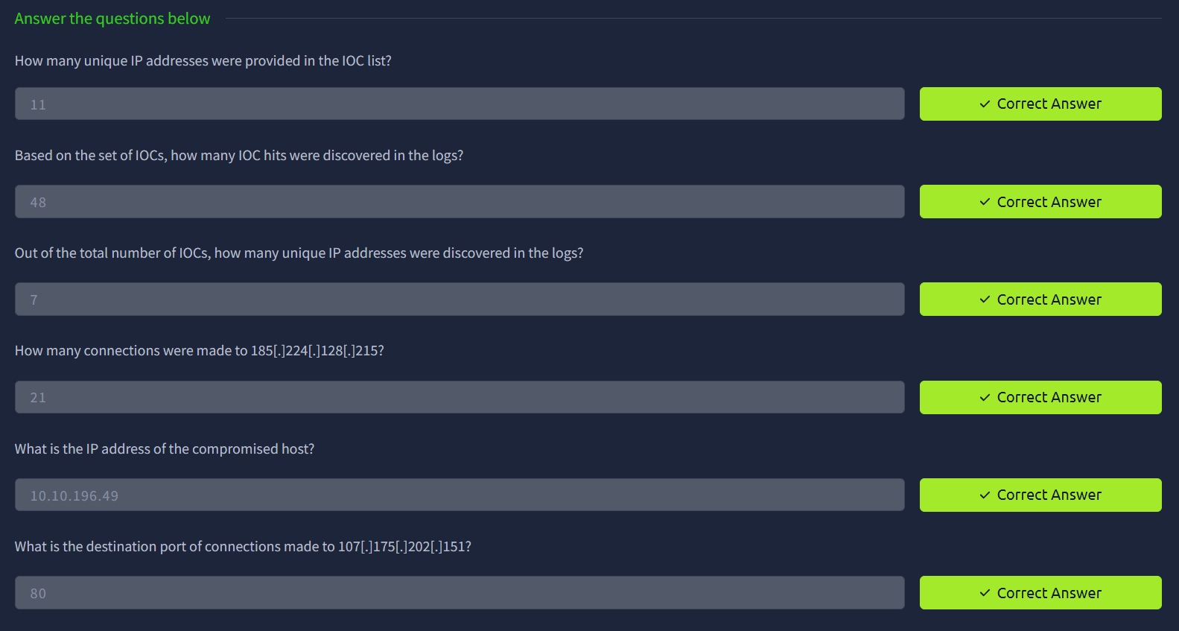

TASK 2 - Intelligence-driven Prevention

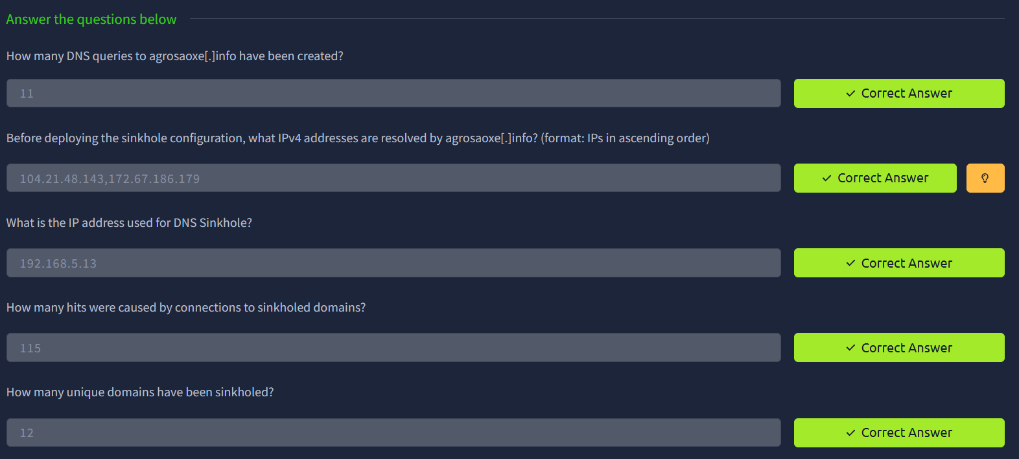

TASK 3 - Intelligence-driven Detection

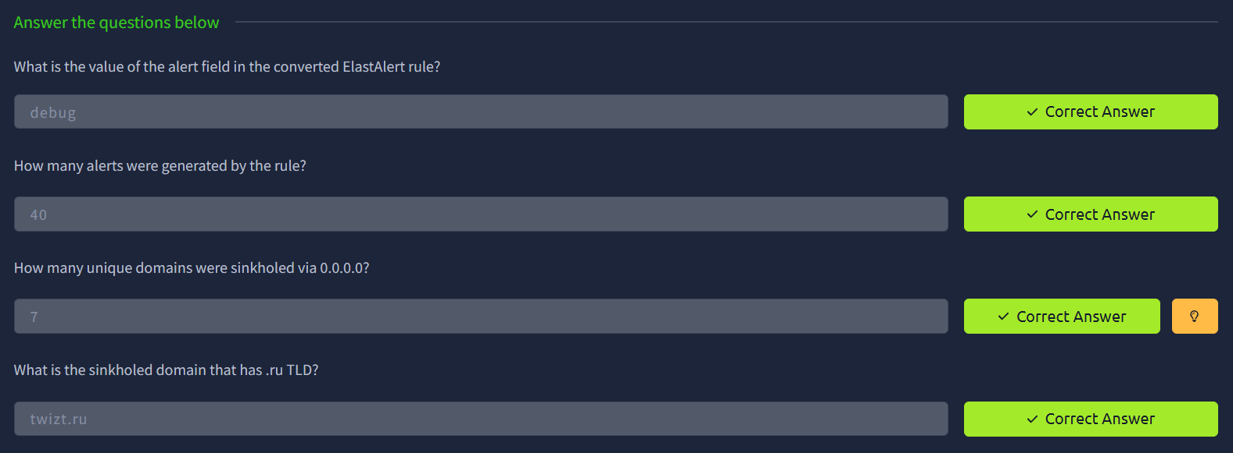

RESULT

Gained knowledge of how threat intelligence helps SOC analysts detect, analyze, and respond to cyber threats effectively.

